Phase 2

CS 4376.0U1

Team 1

Team URL: <https://cs-4376-cyberminer.herokuapp.com/>

**Comet Crawler Web Search Engine System Design Specification: Phase 2**

**Team 1:**

**Areebah Fatima**

**Tyler Hargreaves  
Darrien Kramer**

**Ilhaam Syed**

**Nathan Heindl   
Matthew Bedford**

TABLE OF CONTENTS

1. INTRODUCTION 3
   1. Brief Description of Project Phase 1 3
      1. Purpose 3
      2. Scope 3
   2. Project Phase 2 Description 3
      1. Purpose 4
      2. Scope 4
      3. Assumption 4
      4. Functional Requirements 5
      5. Non-Functional Requirements 5
      6. URL Syntax Context Free Grammar (BNF) 5
   3. Enhanced and Updated Project UP/Road Map 6
      1. Use Case Diagram & Templates 7
      2. Sequence Diagram 8
      3. Class Diagram 16

1. ACTIVITY DIAGRAM 22
   1. Activity Diagram for Search 22
   2. Activity Diagram for Adding URL. 23
   3. Activity Diagram for Deleting URL. 24
   4. Activity Diagram for Modifying URL. 25
   5. Activity Diagram for Managing System Settings. 26
2. STATE DIAGRAM 27
   1. Introduction 27
   2. State Diagram for the Comet Crawler Search Engine 27
3. PACKAGE DIAGRAM 29
   1. Activity Diagram for the Comet Crawler Search Engine 29
   2. Description 29
4. ADDITIONAL POINTS 30
   1. List of additional points and links 30

**1. INTRODUCTION:**

* 1. **BRIEF DESCRIPTION OF PROJECT PHASE 1**
     1. **PURPOSE**

The project's end goal is to create a system that will provide users with relevant information using the keywords entered by the user. The resulting data will be a sorted and filtered list of web page URLs to the end user. The major components of the search engine will include a search interface, indexing system, result filtering, query processing, etc. The search interface will allow the end user to interact with the system, enter search queries, and retrieve information. The indexing system will organize, store, and rank information to allow for a reasonably fast search. Result filtering will ensure that our system provides users with relevant, up-to-date data in sorted order. Finally, the query processing component of the project will be responsible for interpreting user inputs, identifying keywords in said input, performing index lookup, and retrieving results.

This document is the final project report. This document aims to explain our project's Unified Process and highlight all significant project changes. It includes Use Case Diagrams, Sequence Diagrams, and Class Diagrams for our Comet Crawler Web Search Engine.

* + 1. **SCOPE**
* This project strictly focuses on the Comet Crawler Search engine and its additional functions.
* The system comprises a search engine including a search interface, indexing system, result filtering, query processing, etc.
* The system does not have privileges for specific functionalities. Therefore, search users can perform searches, add URL entries, modify the index, delete URL entries, and manage system settings.
* The system allows multiple users to search at the same time.
  1. **PROJECT PHASE 2 DESCRIPTION:**
     1. **PURPOSE:**

The project's end goal is to create a system that will provide users with relevant information using the keywords entered by the user. The resulting data will be a sorted and filtered list of web page URLs to the end user. The major components of the search engine will include a search interface, indexing system, result filtering, query processing, etc. The search interface will allow the end user to interact with the system, enter search queries, and retrieve information. The indexing system will organize, store, and rank information to allow for a reasonably fast search. Result filtering will ensure that our system provides users with relevant, up-to-date data in sorted order. Finally, the query processing component of the project will be responsible for interpreting user inputs, identifying keywords in said input, performing index lookup, and retrieving results.

This document is the final project report. This document aims to explain our project's Unified Process and highlight all major project changes. It includes Use Case Diagrams, Sequence Diagrams, Class Diagrams, Package Diagrams, State Transition Diagrams, and Activity Diagrams for our Comet Crawler Web Search Engine.

* + 1. **SCOPE:**
* This project strictly focuses on the Comet Crawler Search engine and its additional functions.
* The system comprises a search engine including a search interface, indexing system, result filtering, query processing, etc.
* All users can interact with the search engine interface, enter search parameters, perform searches, and redirect themselves to their desired result page.
* Only privileged Administrator users can add URLs, Modify the index, delete URL entries, and manage system settings.
* Privileged Administrator users must log in to ensure their credentials; only then will they be allowed to perform privileged operations.
* The system allows multiple users to search at the same time.
  + 1. **ASSUMPTION:**

The following assumptions constrain the Comet Crawler Search Engine:

* Because we are implementing a long-term-support version of Ruby on Rails, we will be operating under the presumption that HTTP dispatching, database access, and other core functionality is handled appropriately. This design philosophy allows us to consider engineering the search algorithm and other important application-specific features.
* The application is dependent on Rails and its dependencies. A full list of requirements can be found at: [**https://github.com/tyharg/CS-4376/blob/main/Gemfile**](https://github.com/tyharg/CS-4376/blob/main/Gemfile).
  + 1. **Functional Requirements:**

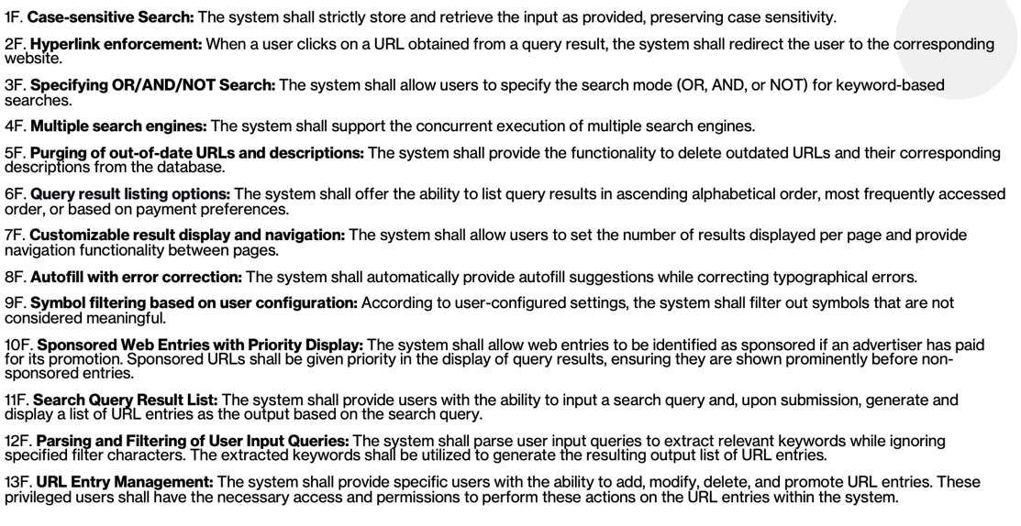

* + 1. **Non-Functional Requirements:**

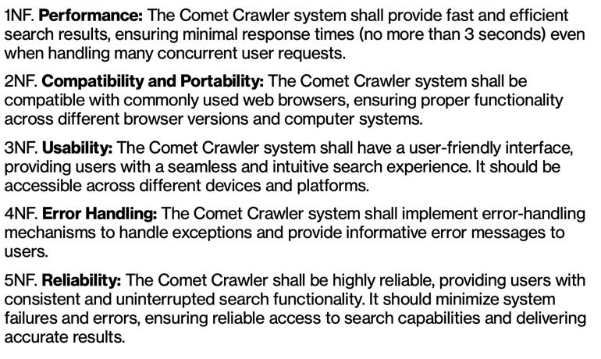

* + 1. **URL Syntax Context Free Grammar (BNF):**

URL ::= {['http://'|'https://']} {www.} Identifier '.' ['edu' | 'com' | 'org' | 'net' | 'gov' | 'mil’]

Identifier ::= ${\text{[letter | digit}]}^{+}$

letter ::= [ 'a' | 'b' | 'c' | 'd' |… | 'y' | 'z' | 'A' | 'B' | 'C' | 'D' | ... | 'Y' | 'Z']

digit ::= ['1' | '2' | '3' | '4' | '5' | '6' | '7' | '8' | '9' | '0']

* 1. **ENHANCED AND UPDATED PROJECT UP / ROAD MAP:**

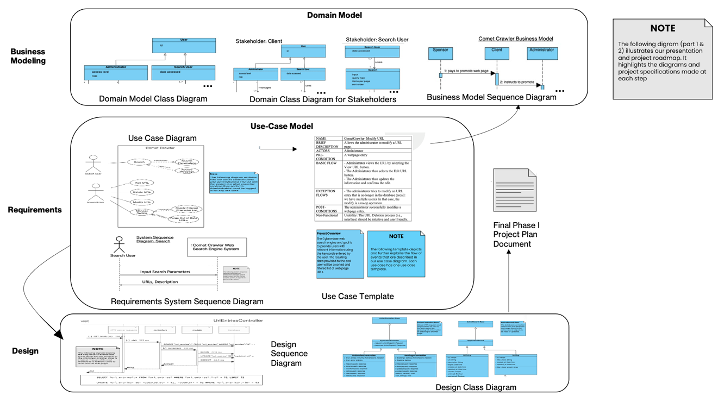

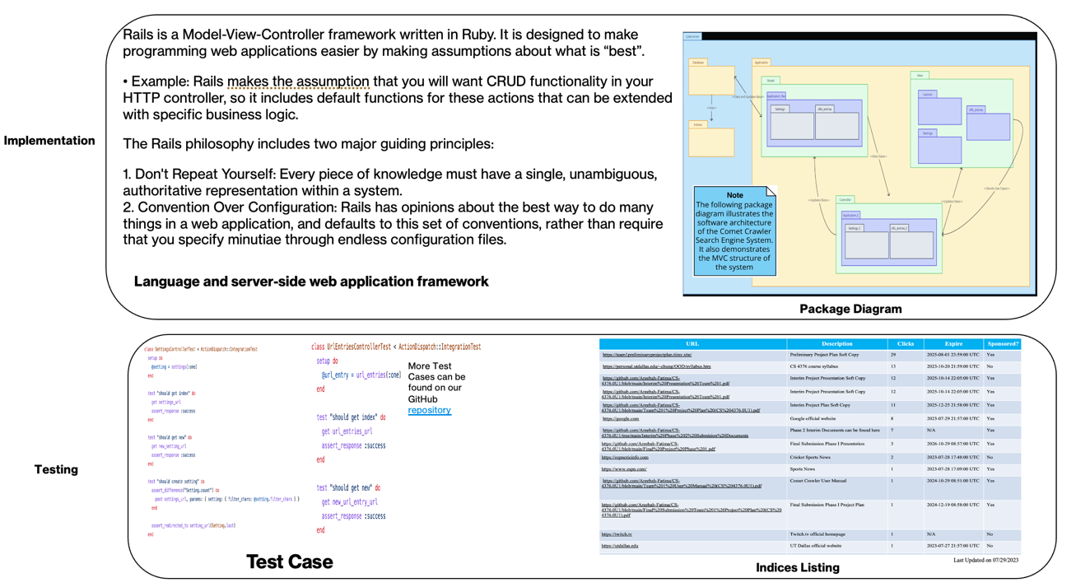

* + 1. **USE CASE DIAGRAM:**

Definition: A use case diagram models the observable behaviors of a system from an actor/user’s perspective. This allows us to communicate essential services and the scope of the system. The main goal of this diagram is to help people understand the system and aid in achieving the client’s primary goals.

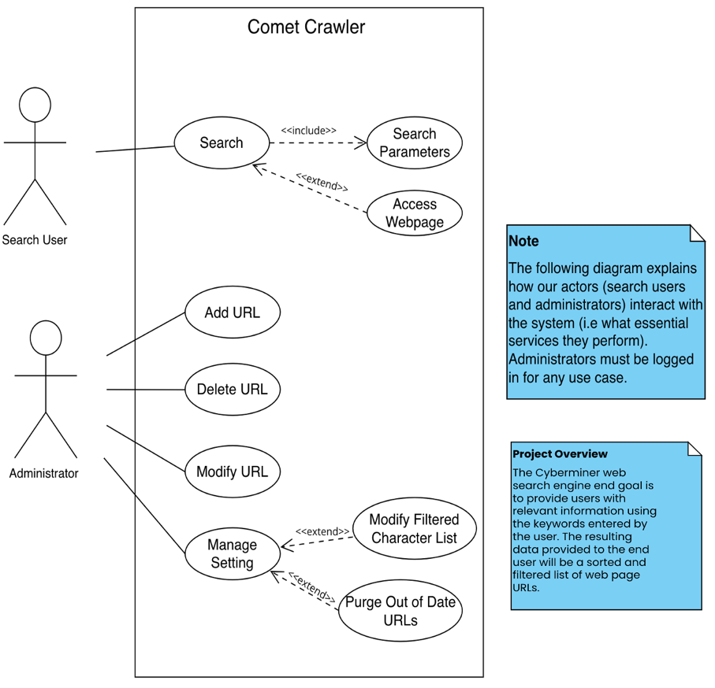

Figure 1.1 Comet Crawler Web Search Engine System Use case diagram (Part of Requirements)

DESCRIPTION:

The Search User actors will enter search parameters to perform a search and have the option to click a URL from their search results list to redirect themselves to a different webpage. Administrator actors will add URLs, delete URLs, modify URLs, and manage system settings. It is assumed they have logged in before performing any such activities.

Associated Use Case Templates:

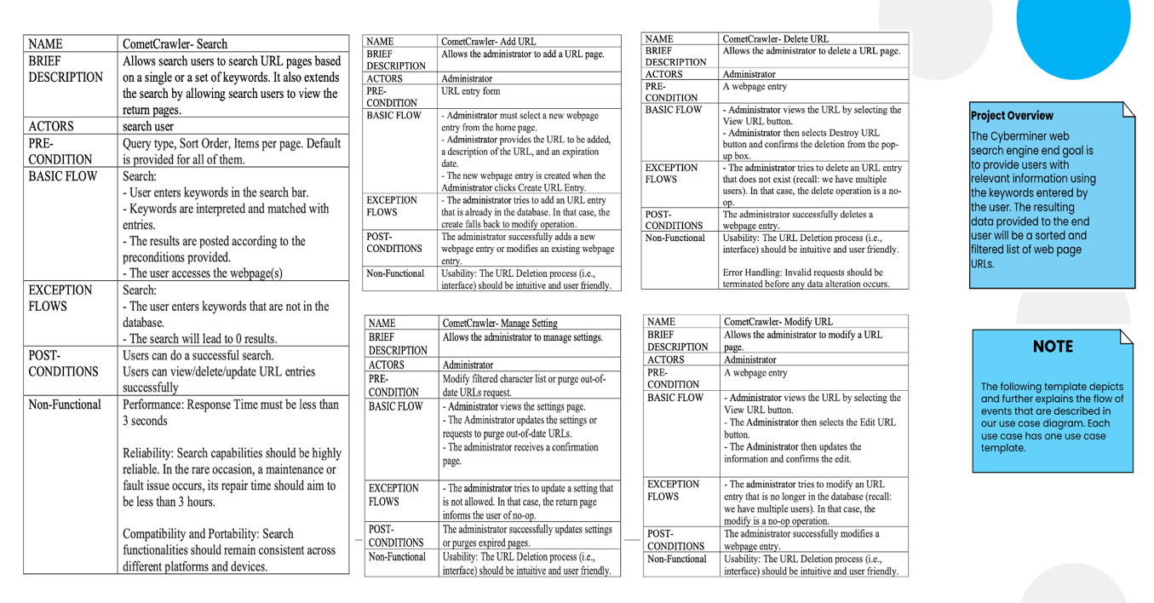

* + 1. **SEQUENCE DIAGRAMS:**

Definition: A sequence diagram models the sequence of interactions (as time flows downward) to help understand and communicate how various system components cooperate to bring a use case functionality into fruition.

**BUSINESS MODEL SEQUENCE DIAGRAMS:**

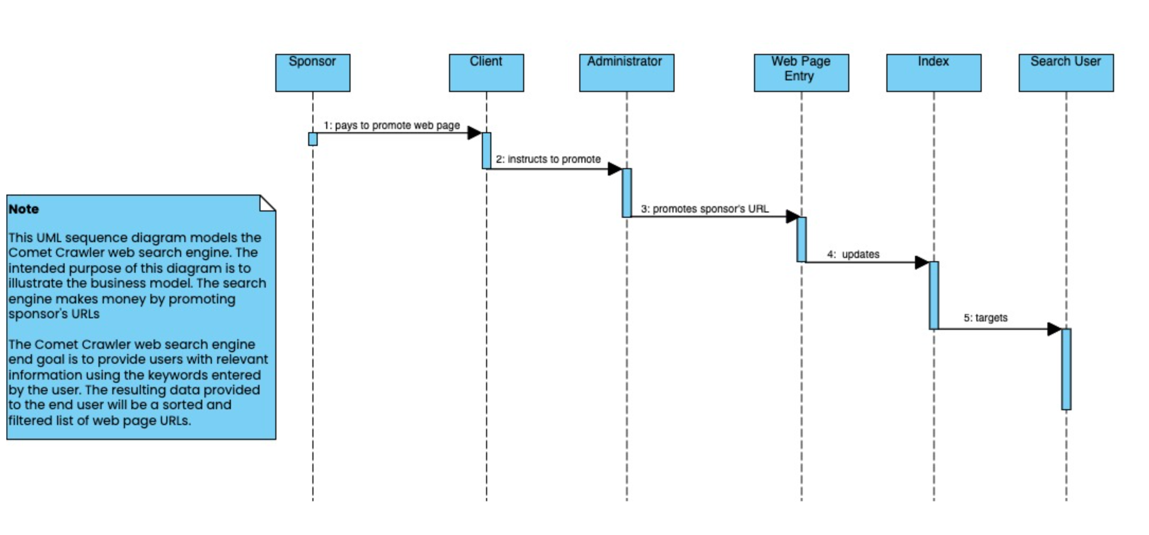

Sequence Diagram to Model the Comet Crawler Web Search Engine’s Business Model

**SYSTEM SEQUENCE DIAGRAMS:**

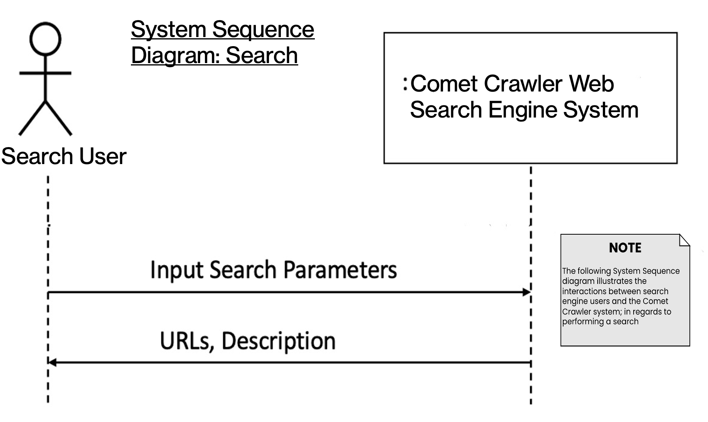

Figure 1.2 Comet Crawler Web Search Engine System Sequence Diagram for Search

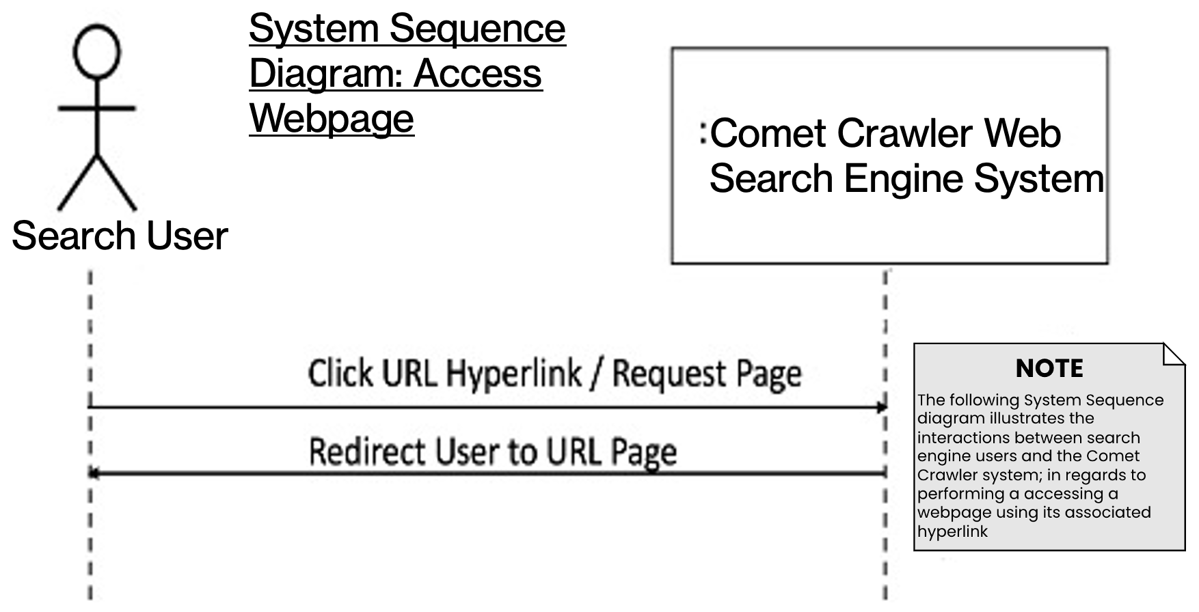

Figure 1.3 Comet Crawler Web Search Engine System Sequence Diagram for Accessing Webpages

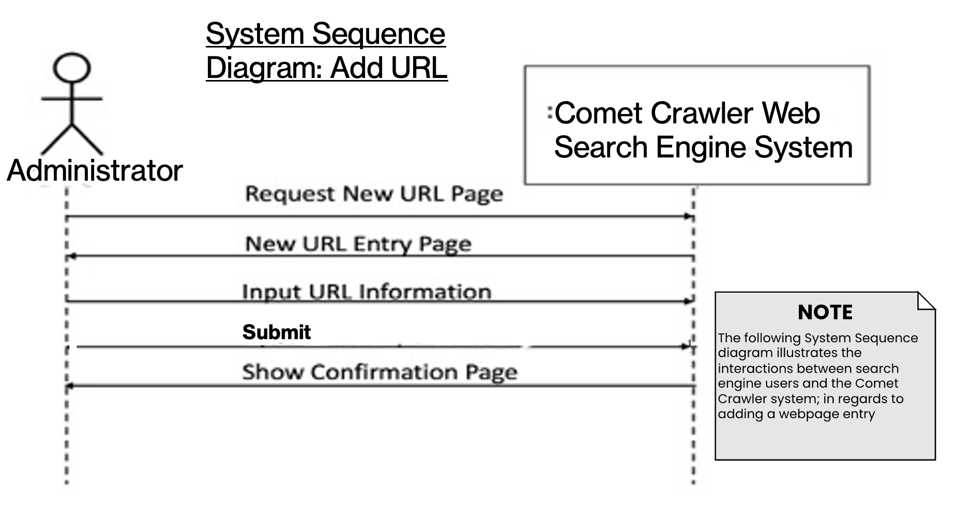

Figure 1.4 Comet Crawler Web Search Engine System Sequence Diagram for Adding URLs

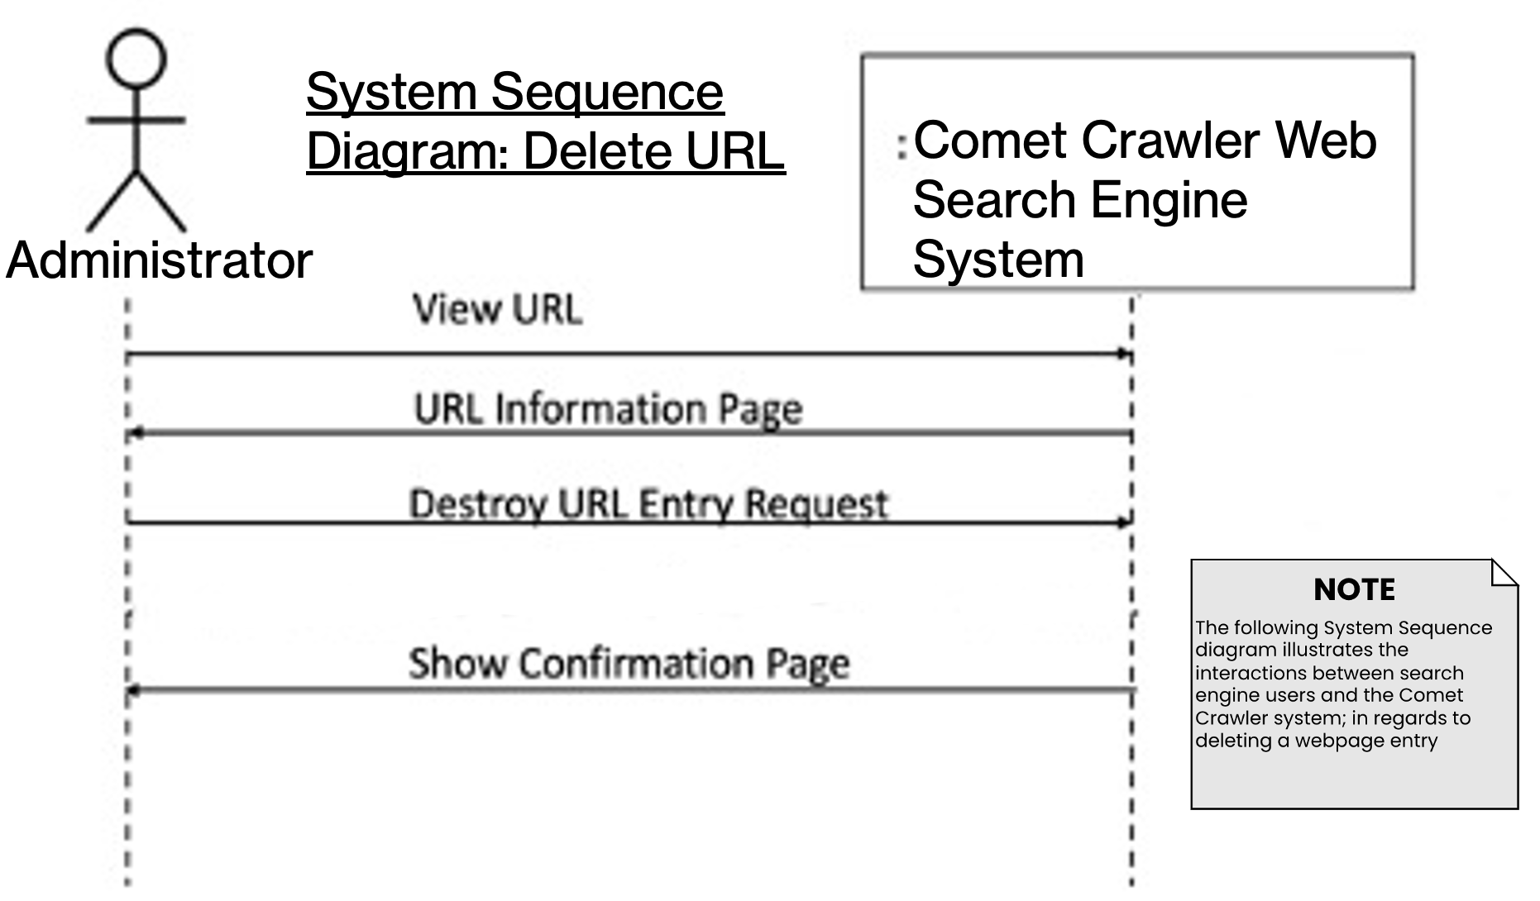

Figure 1.5 Comet Crawler Web Search Engine System Sequence Diagram for Deleting URLs

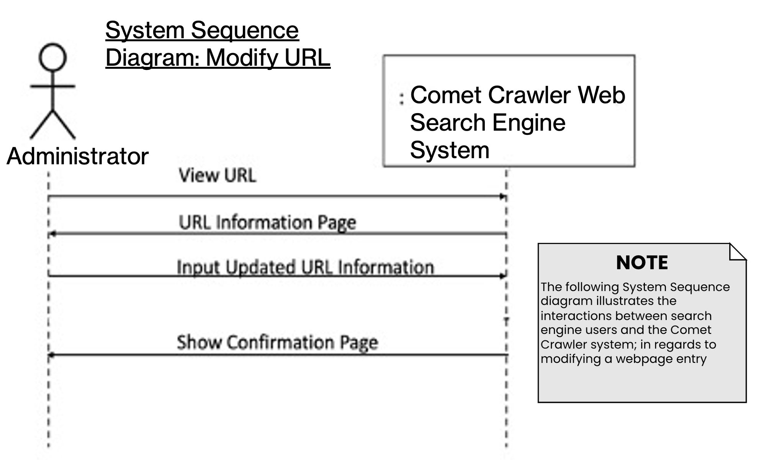

Figure 1.6 Comet Crawler Web Search Engine System Sequence Diagram for Modifying URLs

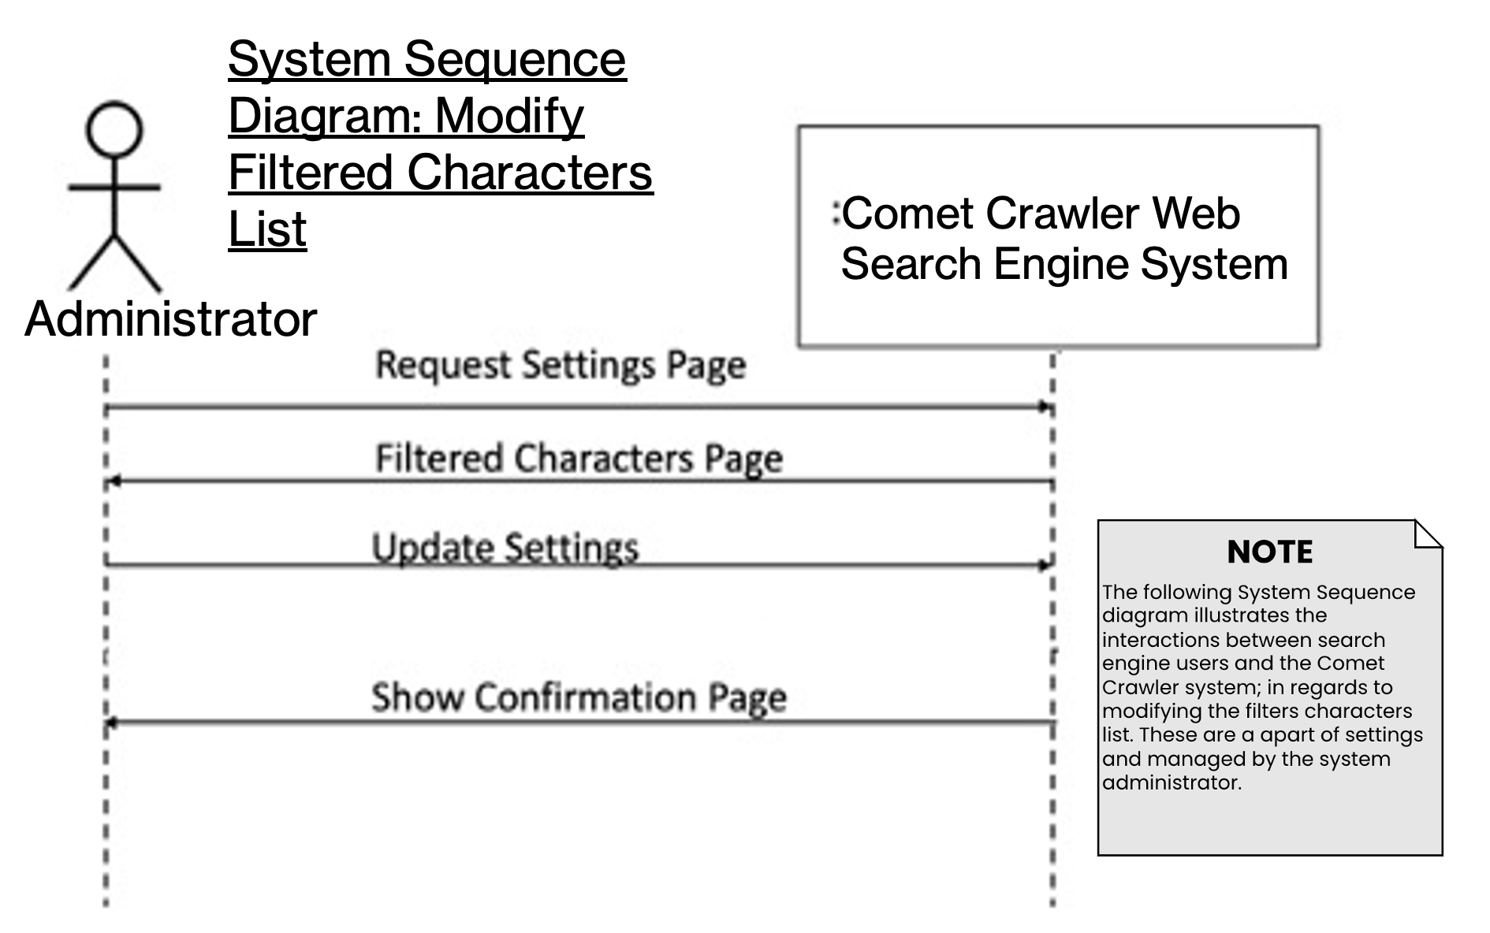

Figure 1.7 Comet Crawler Web Search Engine System Sequence Diagram for Modifying the System Setting’s Filtered Characters List

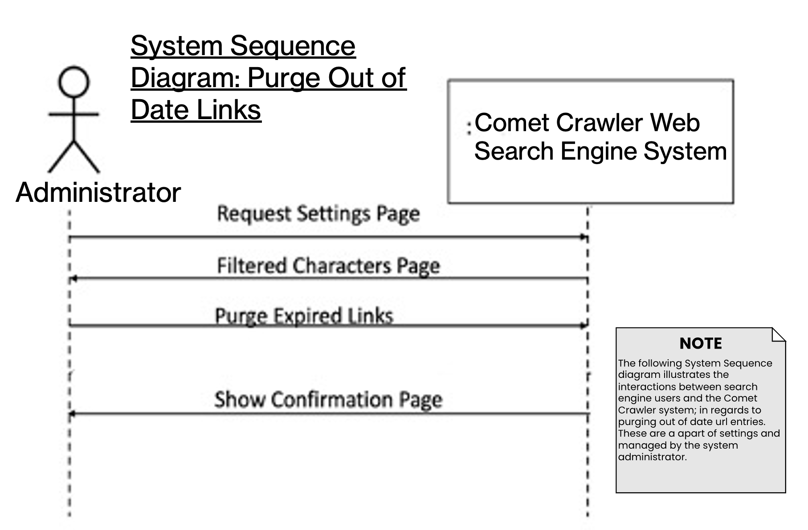

Figure 1.8 Comet Crawler Web Search Engine System Sequence Diagram for Purging Out-of-Date URLs

**DESIGN SEQUENCE DIAGRAM:**

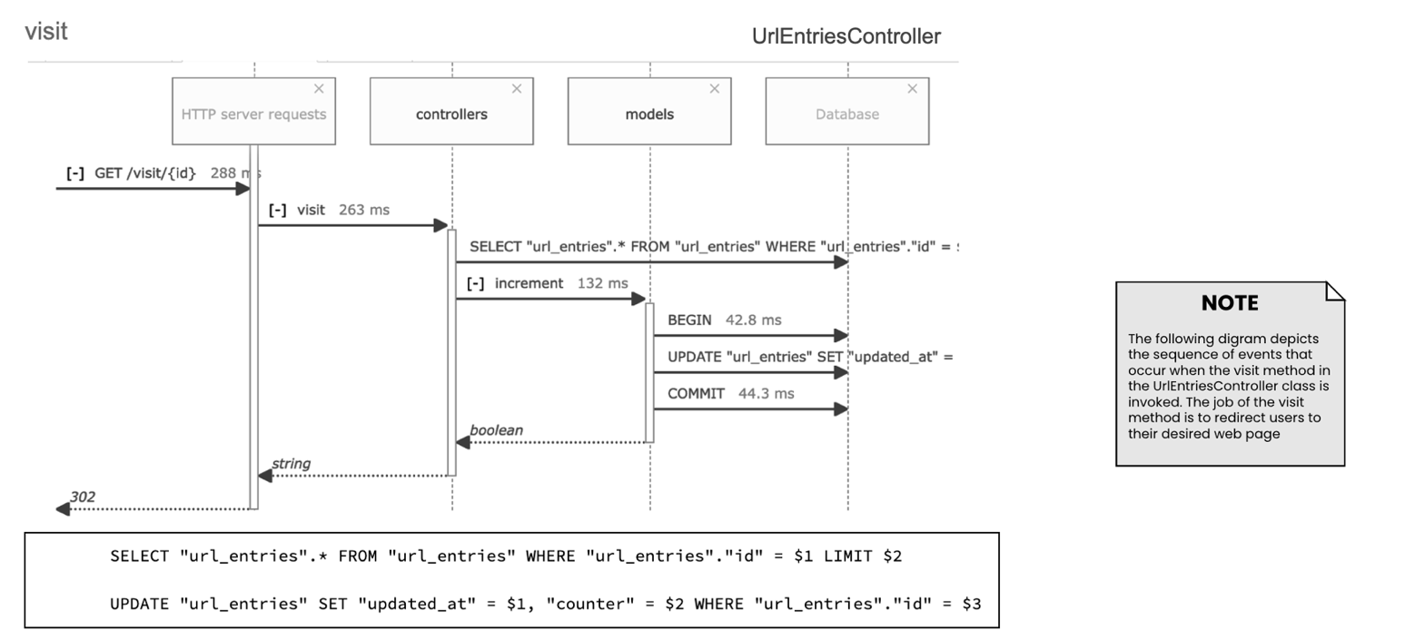

Figure 1.9 Comet Crawler Web Search Engine Sequence diagram for visit function

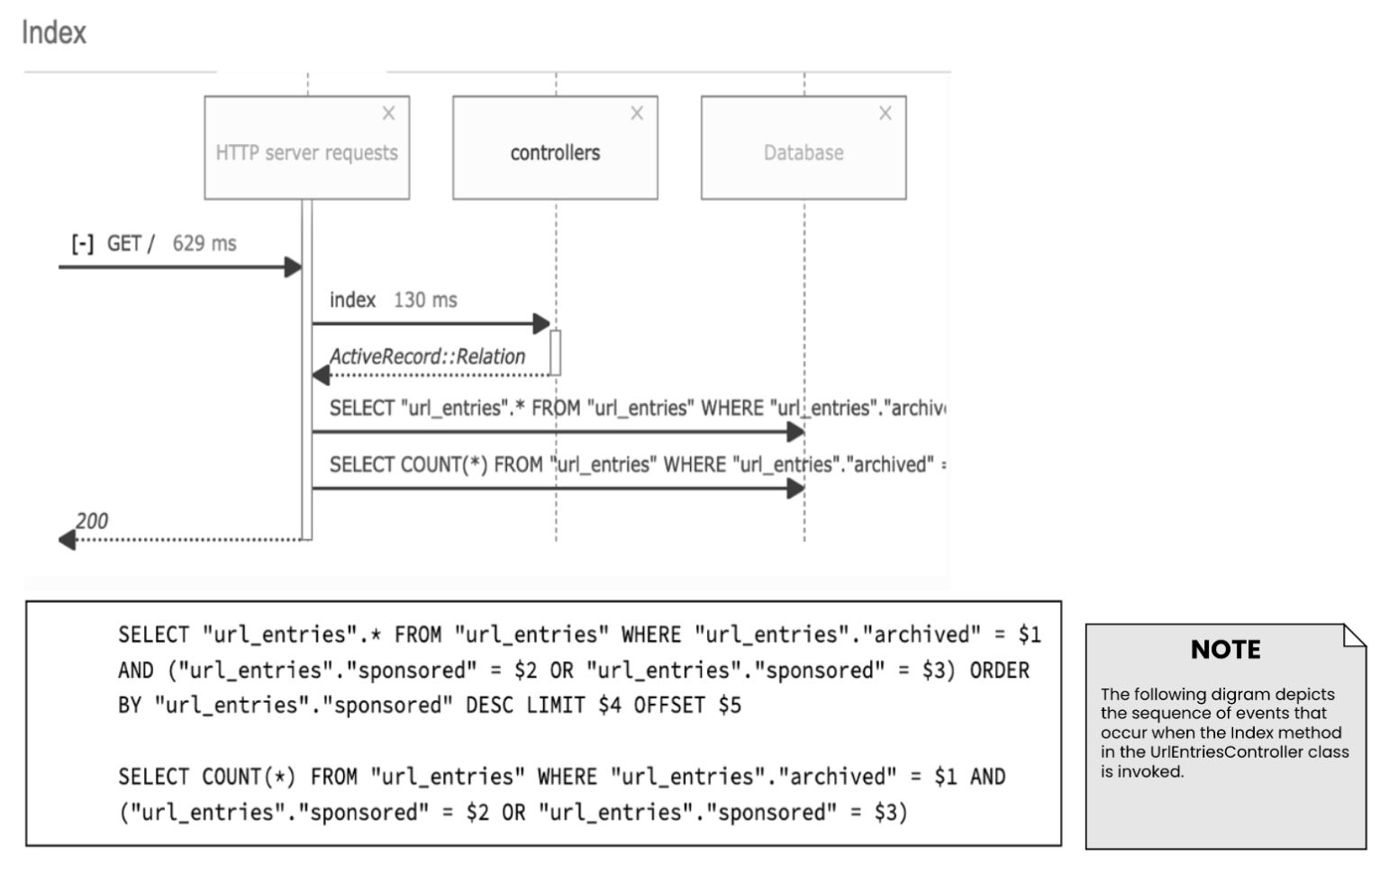

Figure 1.10 Comet Crawler Web Search Engine Sequence diagram for the System’s Index (Part of UrlEntriesController)

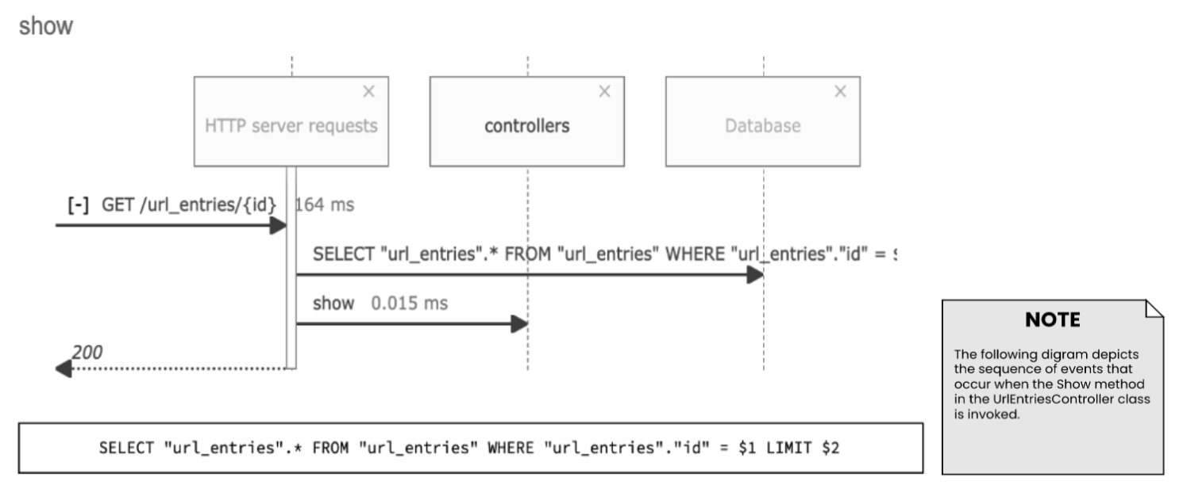

Figure 1.11 Comet Crawler Web Search Engine Sequence diagram for the show function. (Part of UrlEntriesController)

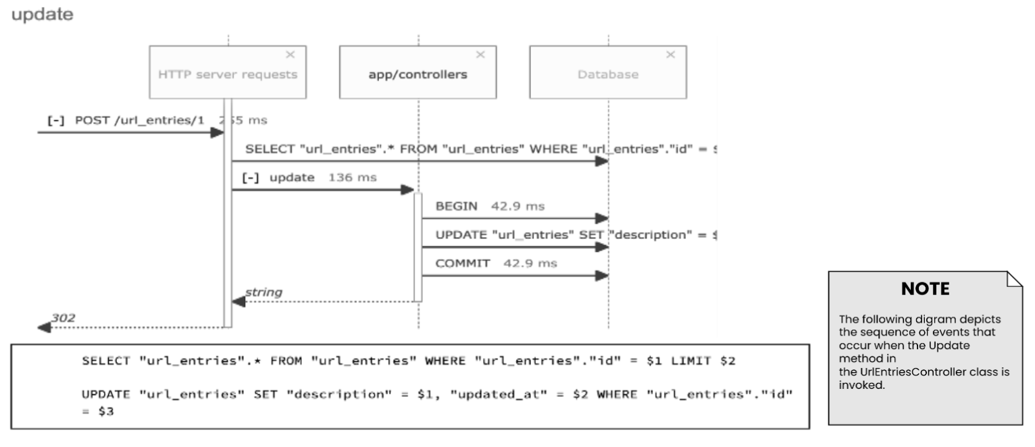

Figure 1.12 Comet Crawler Web Search Engine Sequence diagram for the update function. (Part of UrlEntriesController)

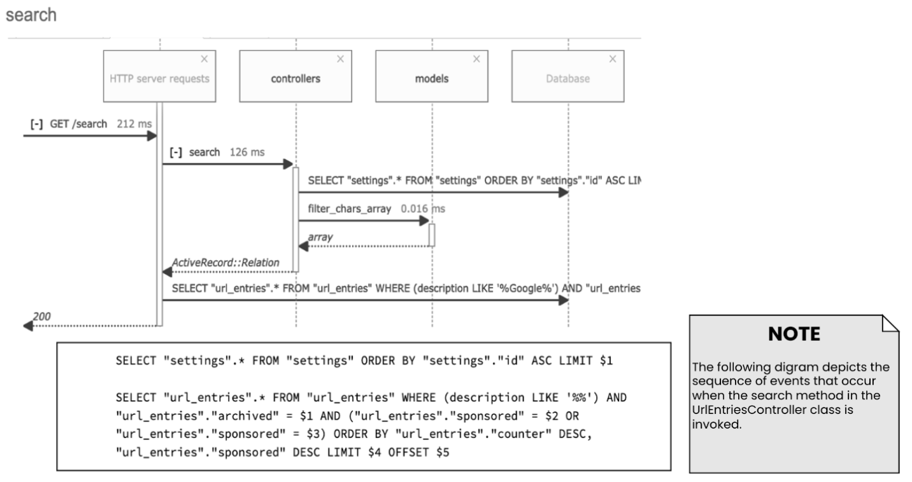

Figure 1.13 Comet Crawler Web Search Engine Sequence diagram for the search function. (Part of UrlEntriesController)

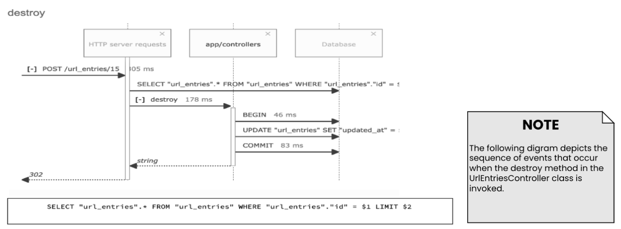

Figure 1.14 Comet Crawler Web Search Engine Sequence diagram for the destroy function. (Part of UrlEntriesController)

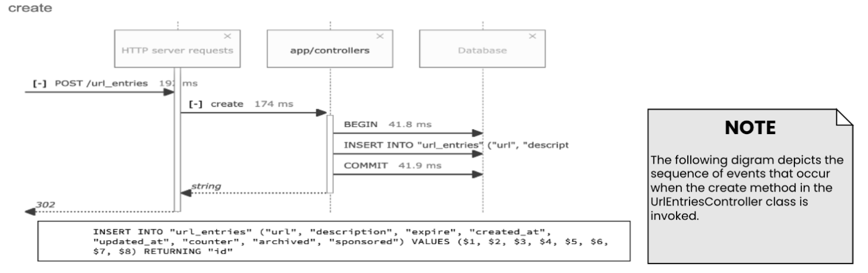

Figure 1.15 Comet Crawler Web Search Engine Sequence diagram for the create function. (Part of UrlEntriesController)

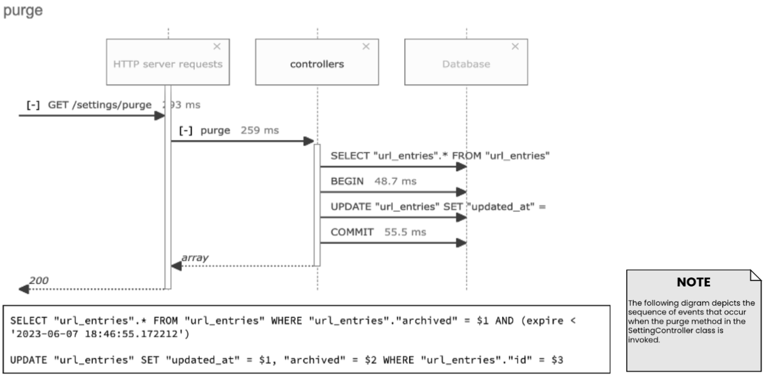

Figure 1.16 Comet Crawler Web Search Engine Sequence diagram for the purging expired links function. (Part of SettingController)

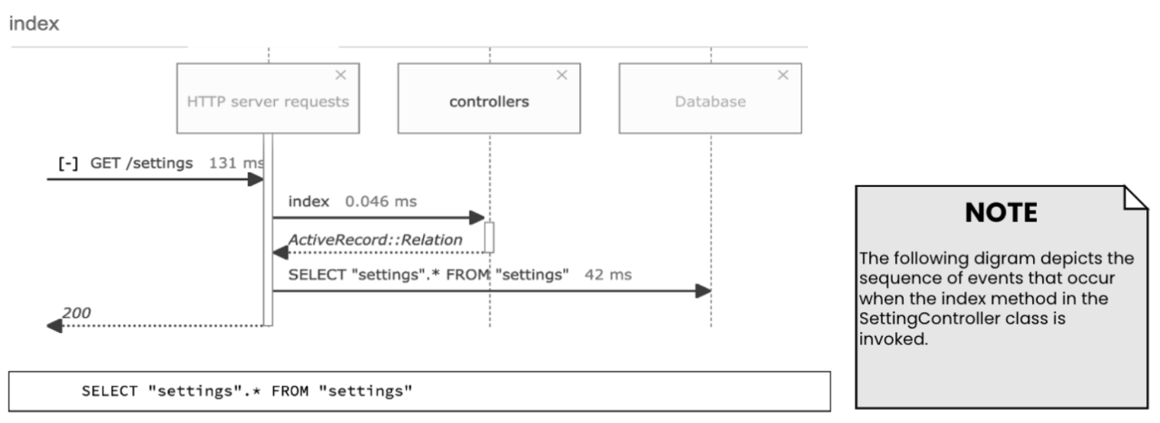

Figure 1.17 Comet Crawler Web Search Engine Sequence diagram for the Setting’s Index. (Part of SettingController)

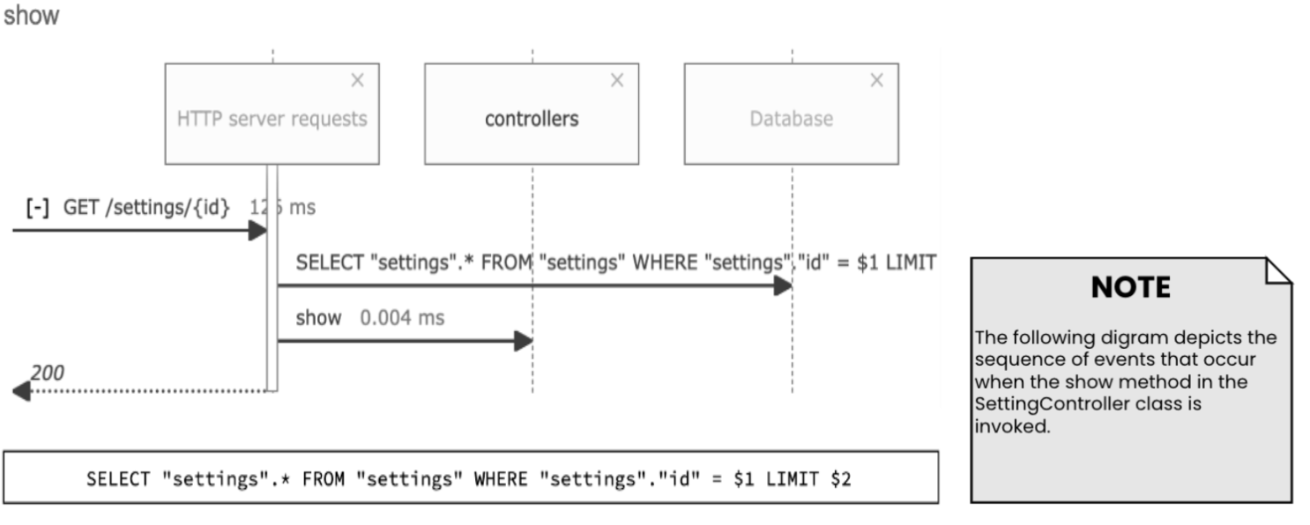

Figure 1.18 Comet Crawler Web Search Engine Sequence diagram for the show settings function. (Part of SettingController)

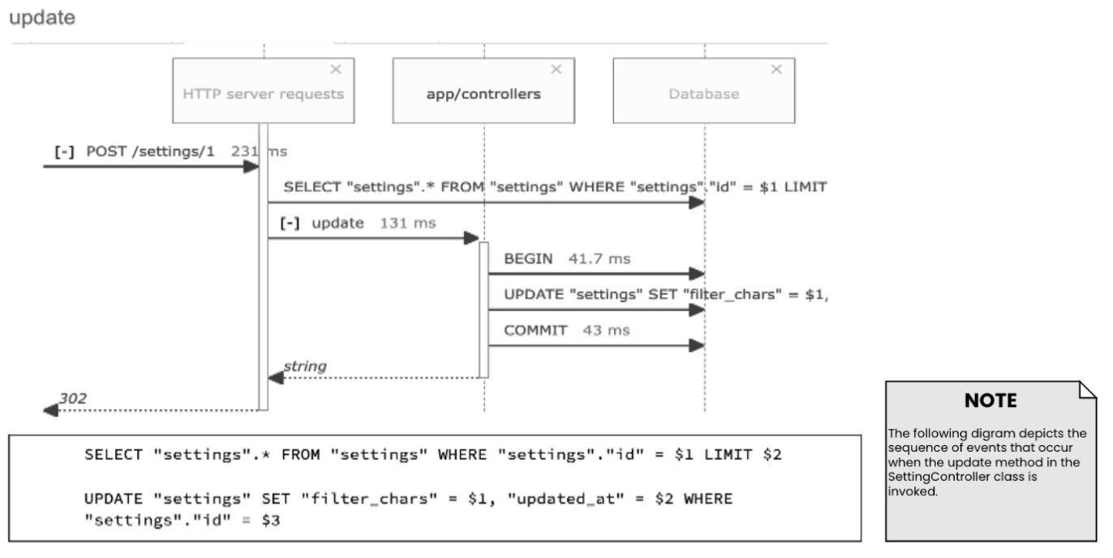

Figure 1.19 Comet Crawler Web Search Engine Sequence diagram for the update settings function. (Part of SettingController)

* + 1. **CLASS DIAGRAM:**

Definition: A class diagram provides a static view of the system’s structure. It highlights key concepts from the problem and solution domain to better understand the structure of classes and how they interact. A class diagram shows classes, class attributes, class methods, and relationships between classes.

**Class Diagram for Domain Model:**

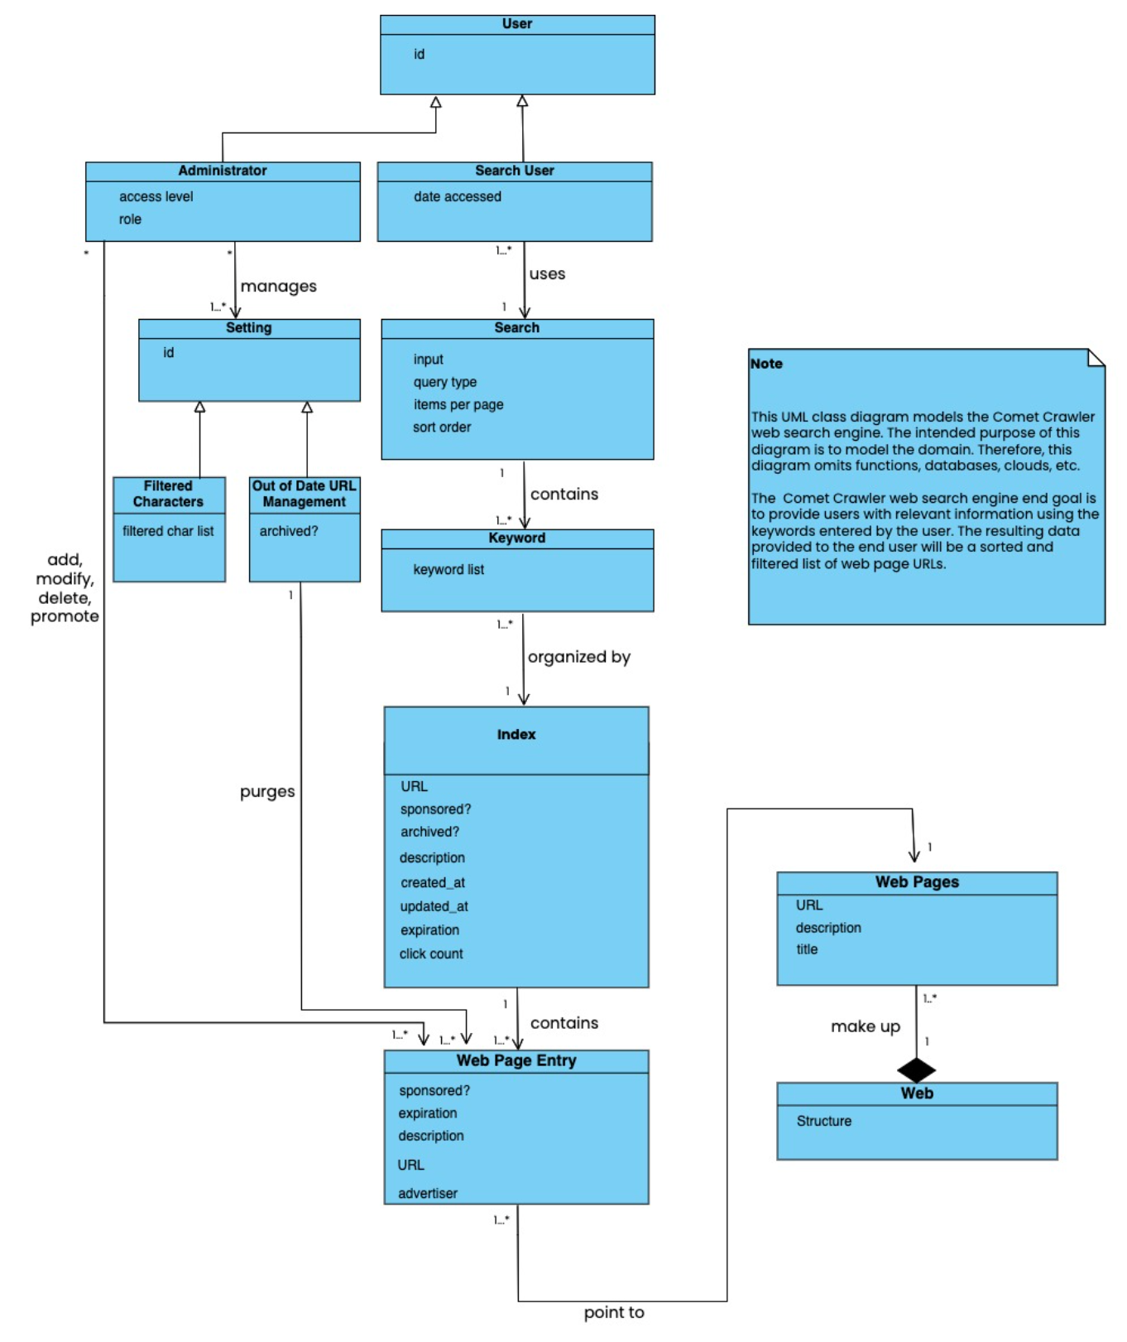

Figure 1.20 Comet Crawler Web Search Engine System Class Diagram

Comet Crawler Stakeholders:

* **Administrator:** Are privileged users with the ability to add, delete, and modify URL entries. In addition to this, they also manage the system filtering and purging settings.
* **Client:** Are the ultimate owner of the project. This ownership allows them to specify project requirements, making them the recipients of project deliverables and the resulting product.
* **Sponsor:** Are the individuals that pay money to promote their websites to the top of the search result list. Stakeholders are the central piece of the business model as they bring monetary incentives for clients.
* **Search Users:** Are the individuals who interact with the Comet Crawler System. They will provide the search parameters and view the associated results. Sponsors will target these users.

**Class Diagrams Based on Stakeholder Views:**

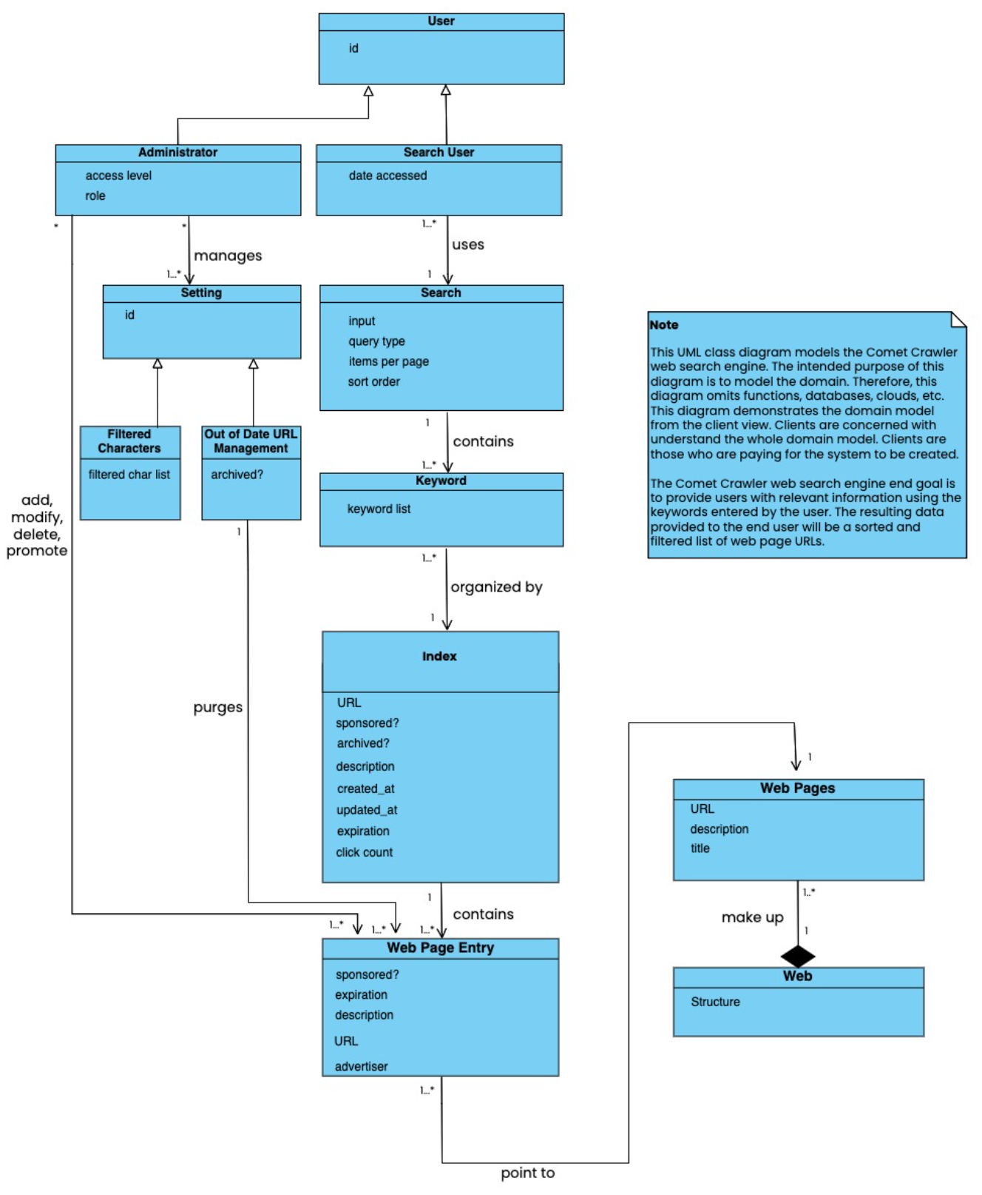

Figure 1.21 Comet Crawler Web Search Engine System Class Diagram (Based on Client’s View)

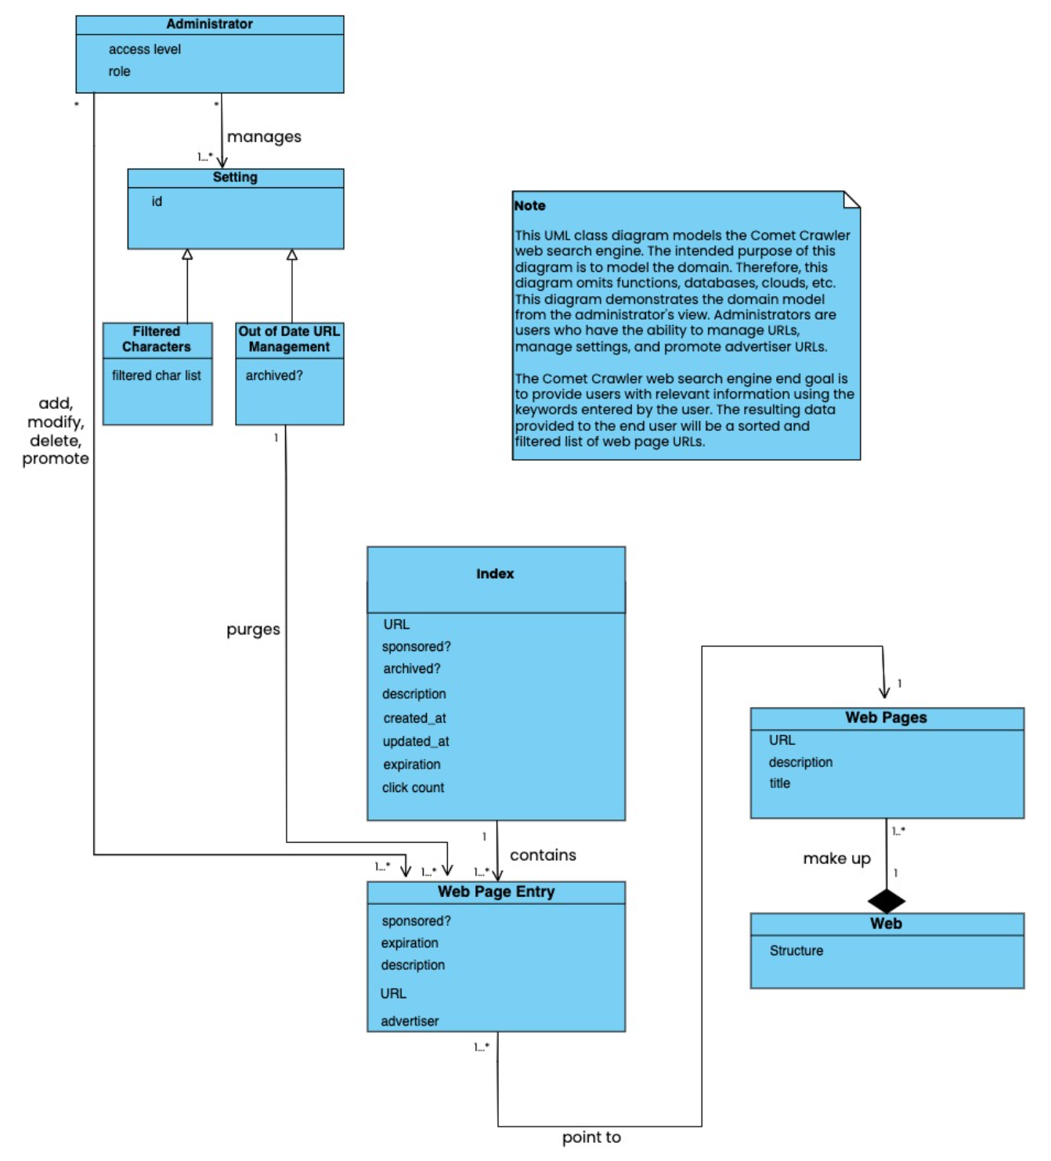

Figure 1.22 Comet Crawler Web Search Engine System Class Diagram (Based on Administrator’s View)

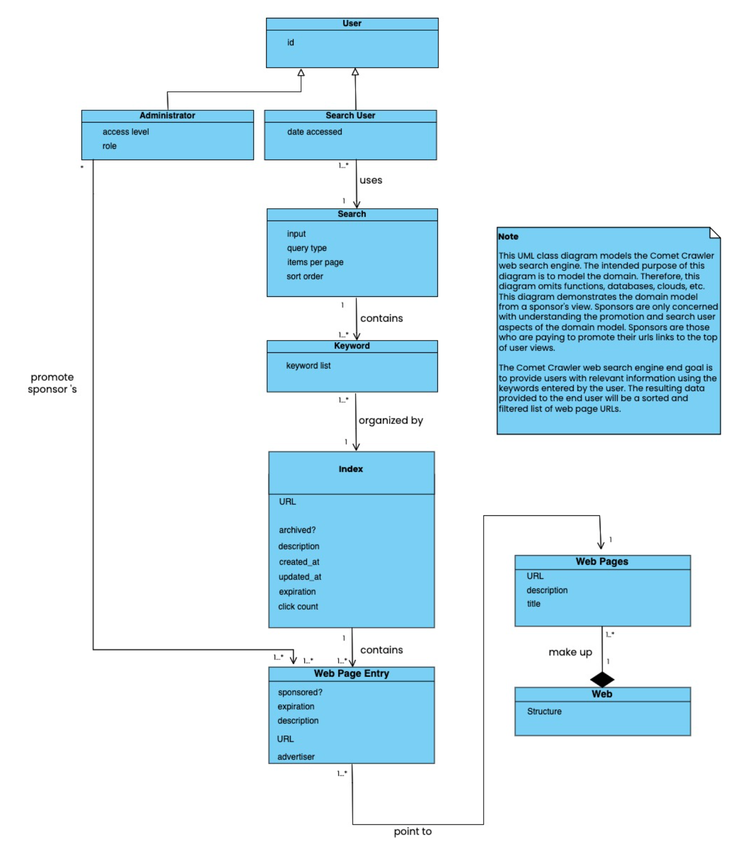

Figure 1.23 Comet Crawler Web Search Engine System Class Diagram (Based on Sponsor’s View)

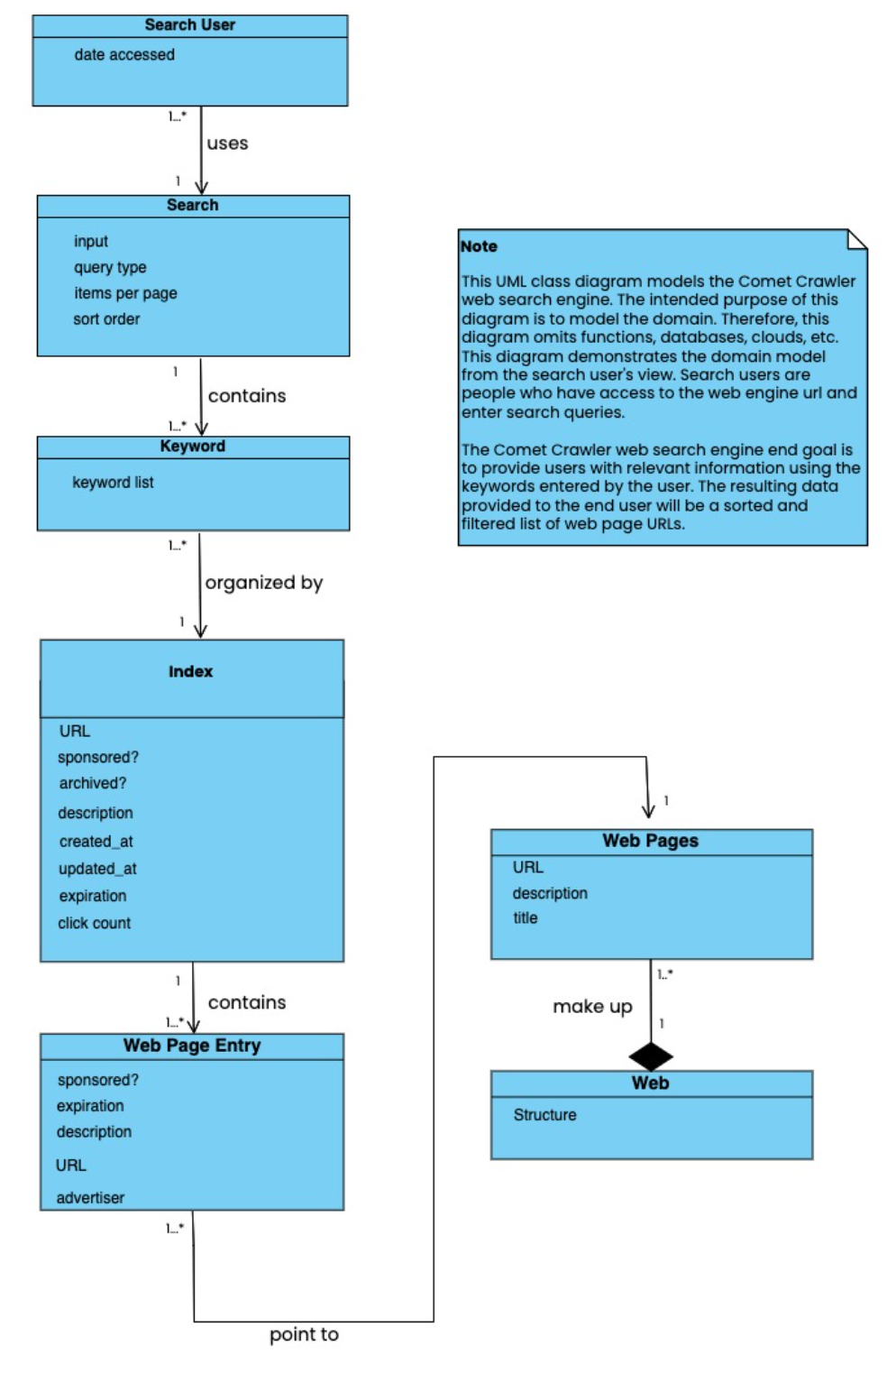

Figure 1.24 Comet Crawler Web Search Engine System Class Diagram (Based on Search User’s View)

**Design Class Diagrams:**

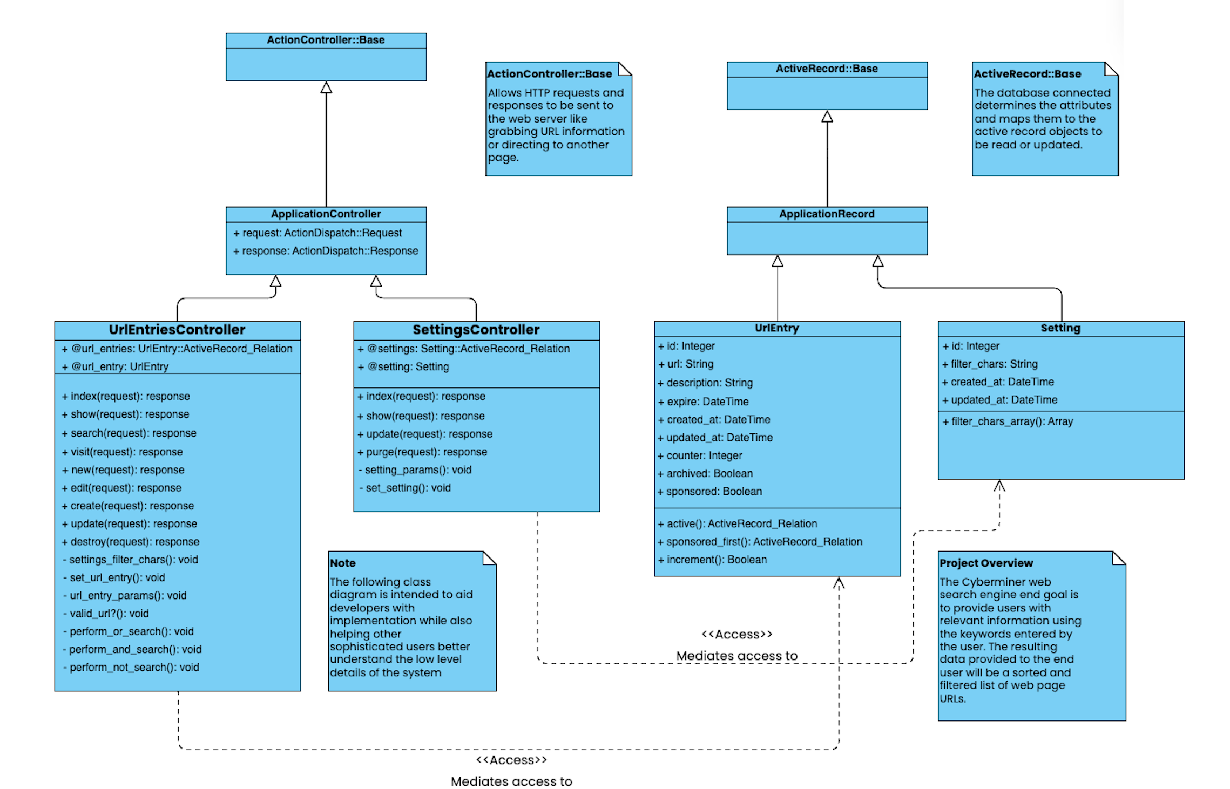

Figure 1.25 Comet Crawler Web Search Engine System’s Design Class Diagram

**2.** **ACTIVITY DIAGRAM:**

Definition: Activity diagrams are used to model the flow of activities and actions a system performs.

**ACTIVITY DIAGRAM FOR THE COMET CRAWLER WEB SEARCH ENGINE SYSTEM:**

**2.1**

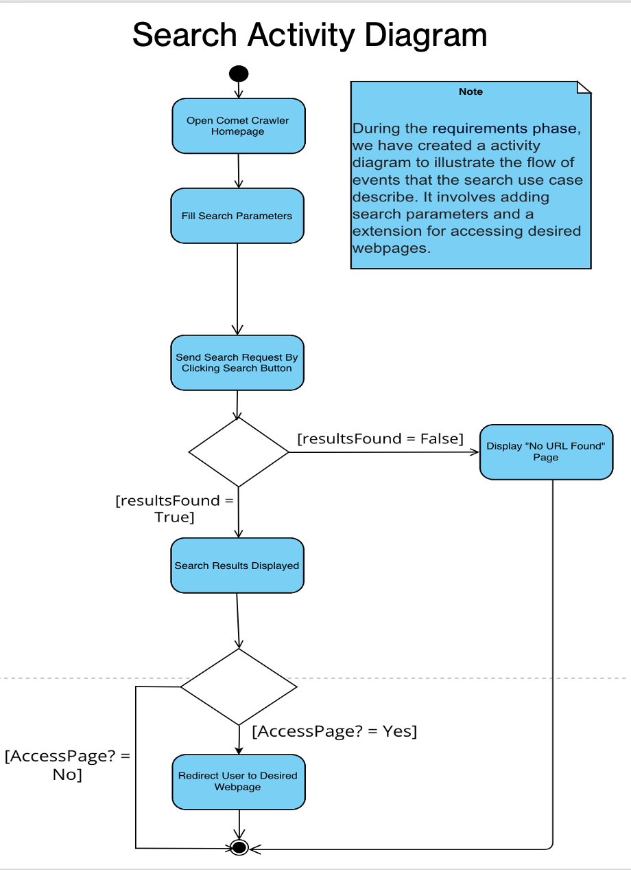

Figure 2.1 Comet Crawler Web Search Engine System’s Activity diagram demonstrates the actions that are involved in a search.

**2.2**

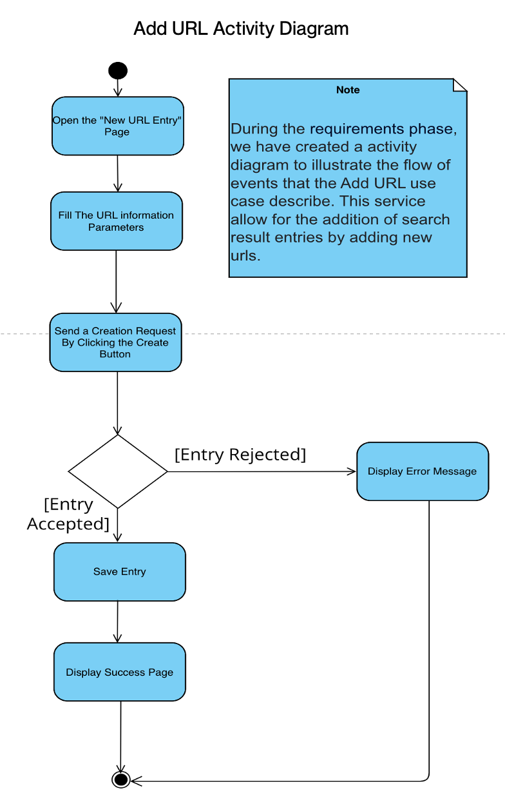

Figure 2.2 Comet Crawler Web Search Engine System’s Activity diagram to demonstrate the actions that are involved in adding a URL.

**2.3**

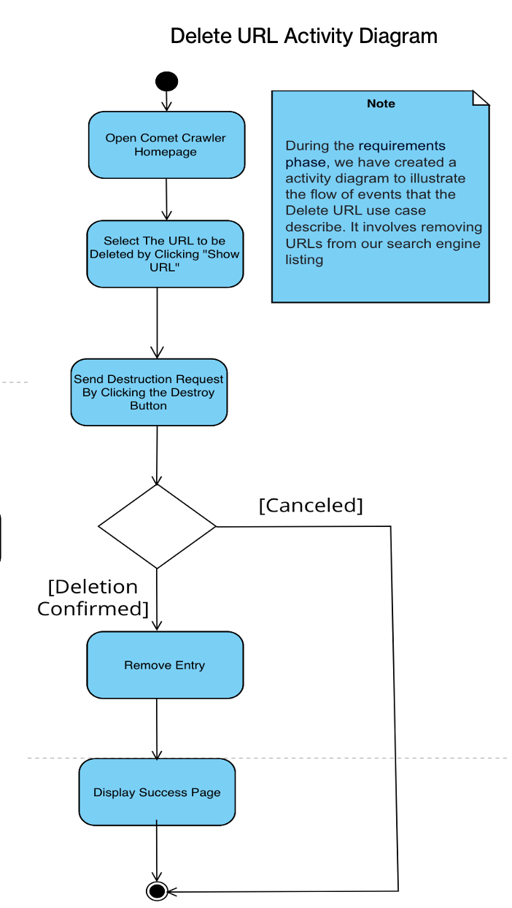

Figure 2.3 Comet Crawler Web Search Engine System’s Activity diagram to demonstrate the actions that are involved in deleting a URL.

**2.4**

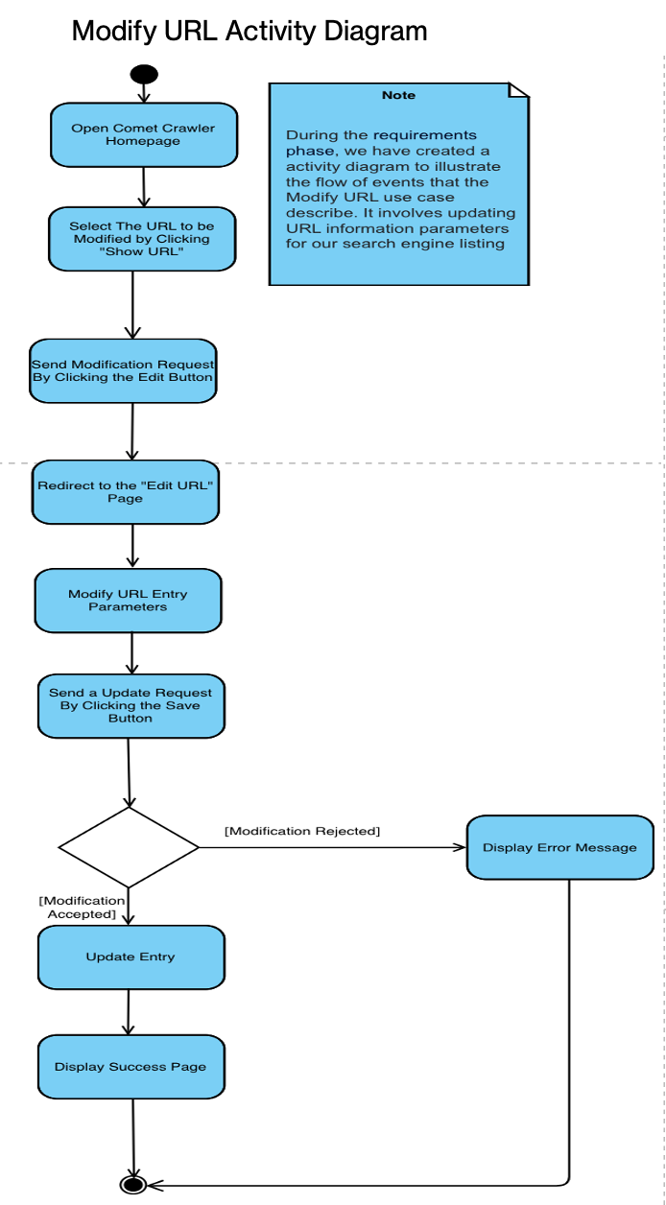

Figure 2.4 Comet Crawler Web Search Engine System’s Activity diagram to demonstrate the actions that are involved in modifying a URL.

**2.5**

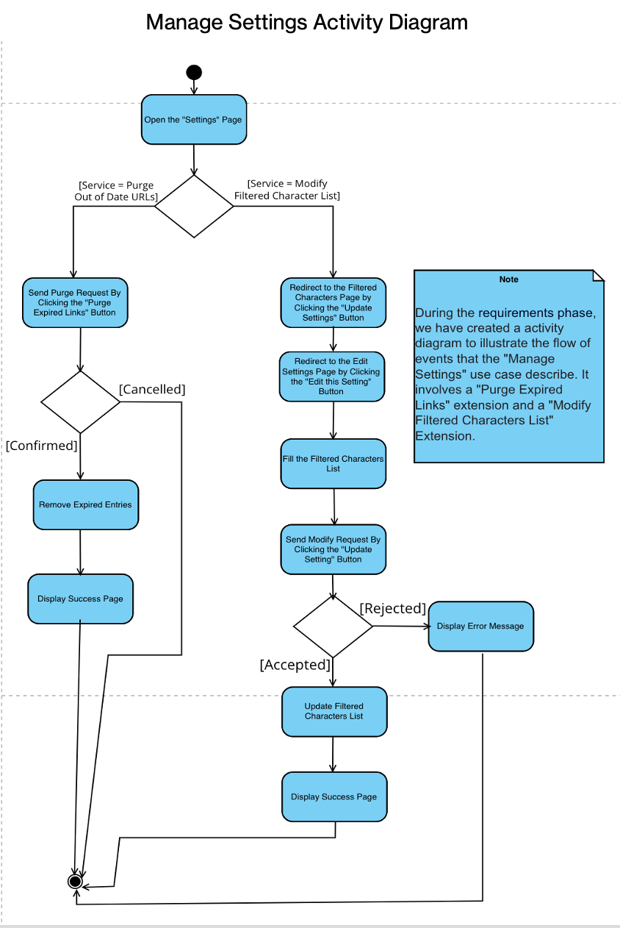

Figure 2.5 Comet Crawler Web Search Engine System’s Activity diagram demonstrates the actions that are involved in managing the system’s settings.

**3. STATE DIAGRAM:**

**3.1 INTRODUCTION:**

State diagrams (also called state chart diagrams) model the state transitions a system will experience in its existence. This helps understand the behavioral aspects of the system.

We have two State diagrams: one to show the state transitions the system will go through with search user operations and one to show the state transitions the system will go through with administrator operations.

**3.2 STATE DIAGRAMS FOR THE COMET CRAWLER WEB SEARCH ENGINE SYSTEM:**

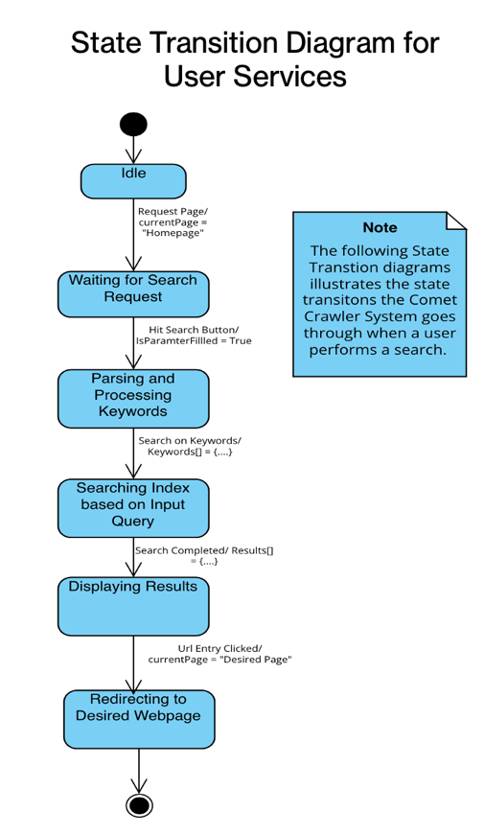

Figure 3.1 State Diagram for User Services (Specifically Searching)



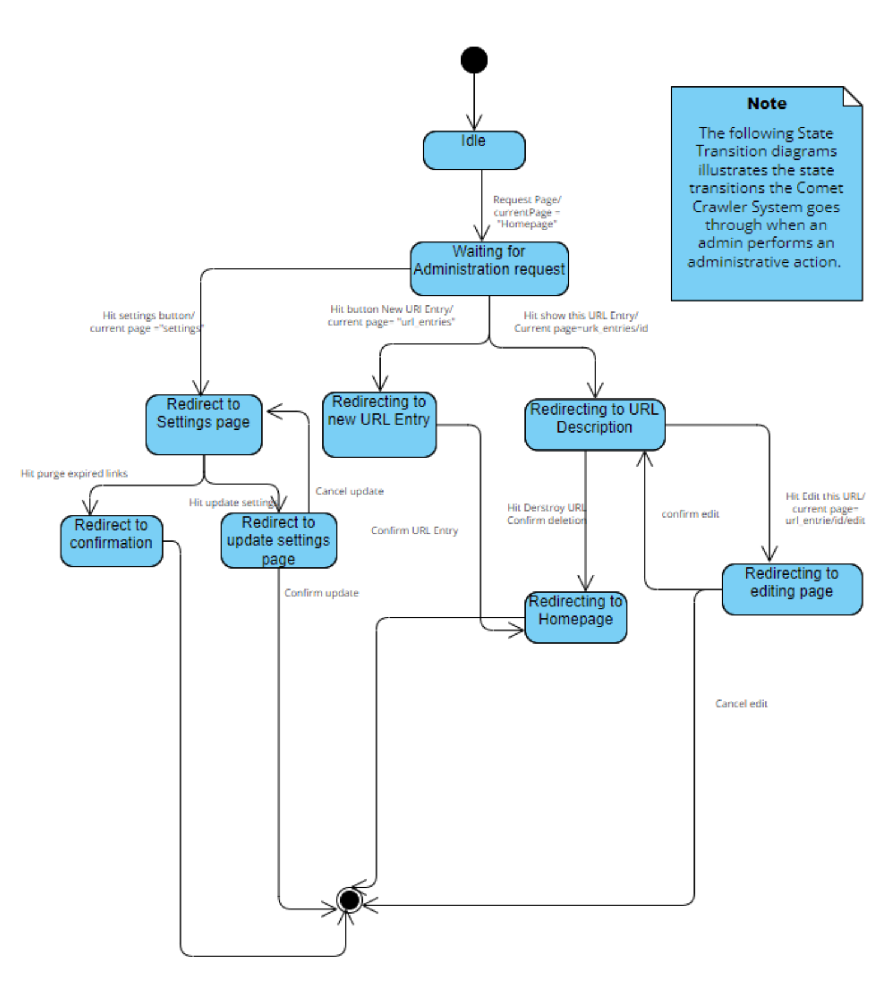

Figure 3.1 State Diagram for Administrator Services (Add/Delete/Modify/Manage System Settings)

**4. PACKAGE DIAGRAM:**

Definition: Package diagrams aim to communicate and model a system’s architecture. It visualizes the grouping of components, classes, interfaces, etc., to present a high-level view of the system.

**4.1 PACKAGE DIAGRAM FOR THE COMET CRAWLER WEB SEARCH ENGINE SYSTEM:**

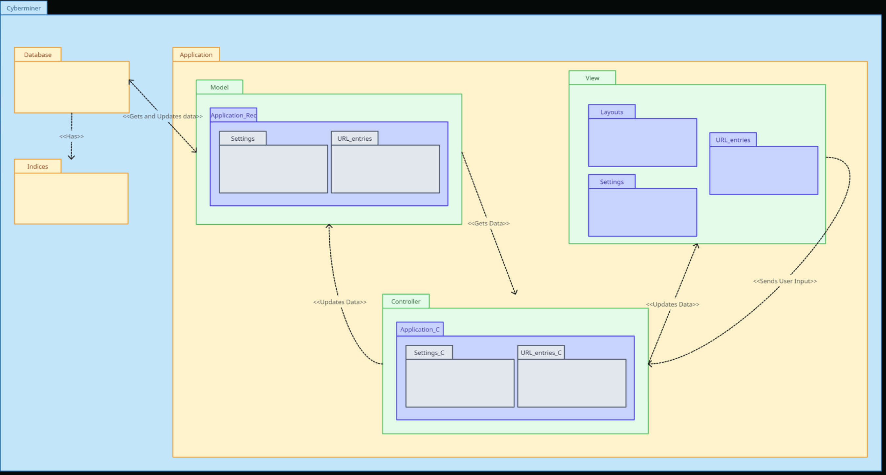Figure 4.1 Package Diagram for The Comet Crawler System

**4.2** **DESCRIPTION:**

* The System has two major components the search engine (Application Package) and the Index (Indices Package).
* The index and model will interact or relate to the database, as shown in the above diagram.
* The system uses the Model-View-Controller Architectural Pattern (MVC). Therefore, we have 3 packages (Model, View, and Controller)

**5. Additional Points:**

**5.1 List of Additional Points and Links**

1. All our test cases can be found here: <https://github.com/tyharg/CS-4376/tree/main/test>
2. The User Manual can be found here: [User Manual](https://github.com/Areebah-Fatima/CS-4376.0U1/blob/main/Phase%20II%20Submission%20Documents/Team%201%20User%20Manual%20(CS%204376.0U1).pdf)
3. The Updated Preliminary Project Plan can be found here: [Up to Date Preliminary Project Plan](https://github.com/Areebah-Fatima/CS-4376.0U1/blob/main/Phase%20II%20Submission%20Documents/Team%201%20Preliminary%20Project%20Plan%20(CS%204376.0U1).pdf)